CIT-227-046/2023
Desmond Mwaka
Software Engineering

File 1: quicksortAssignment.py

import time
from matplotlib import pyplot as plt
import pandas as pd

#the quicksort algo
def quicksort(iter):
if len(iter)<=1:
return iter
else:
pivot=iter.pop()

items_less=[]
items_greator=[]

for item in iter:
if(item<pivot):
items_less.append(item)
else:
items_greator.append(item)
return quicksort(items_less)+[pivot]+quicksort(items_greator)

#list example
vals=[1,0,5,2,3,9,5,4,6]
n=len(vals)

#duration
start=time.perf_counter()
quicksort(vals)
stop=time.perf_counter()
duration=stop-start

#saving duration and n to csv file
data = {
'n': [n],
'time': [duration]
}

df = pd.DataFrame(data)
try:
df.to_csv('duration.csv', mode='a', header=False, index=False)
print("New data successfully added")
except :
print(f"An error occurred")
#read stored data
df=pd.read_csv(r"duration.csv")

x=df["n"]
y=df["time"]
#visualize
plt.plot(x,y,marker='o')
plt.title("Time Complexity of Quicksort")
plt.xlabel("n")
plt.ylabel("time for exection")
plt.show()

File 2: duration.csv

"n","time"
1,1.838998286984861e-06
2,6.547998054884374e-06
3,6.745998689439148e-06
4,9.923001925926656e-06
5,8.643000910524279e-06
6,1.1473995982669294e-05
7,1.55930028995499e-05
8,1.1416996130719781e-05
9,1.6498001059517264e-05

File3: results.png
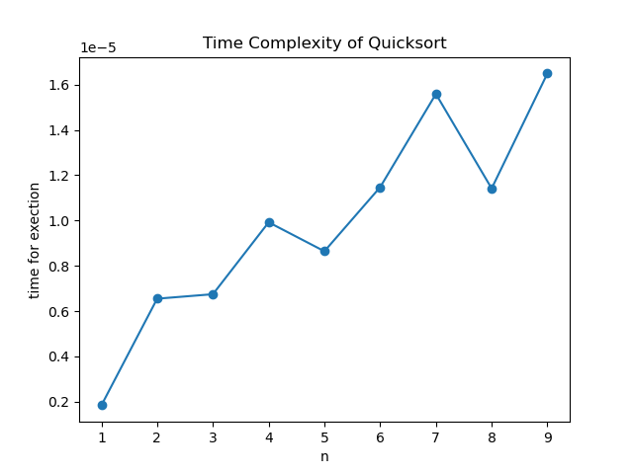

Observations
- Execution time increases as the input size increases.
- There are some instances where a smaller list takes more time than a slightly larger.

Conclusions
Based on the experiment,the time taken by Quicksort increases with the size of the input list.

